# Lesson 88 单词讲解

1 trap [træp] v.陷入，使陷于困境

2 surface ['sə:fis] n.地面，表面

3 explosive [ik'spləusiv] n.炸药

4 vibration [vai'breiʃən] n.震动

5 collapse [kə'læps] v.坍塌

6 drill [dril] v.钻孔

7 capsule ['kæpsju:l] n.容器

8 layer ['leiə] n.层

9 beneath [bi'ni:θ] prep.在…之下

10 lower ['ləuə] v.放下，降低

11 progress ['prəugres, prə'gres] v.进展，进行

12 smoothly ['smu:eli] ad.顺利地

1. trap v. 陷入，使陷入困境

be trapped in a mine

1. drill v. 钻孔

drill a hole

1. beneath prep. 在……之下

beneath the soil

# Lesson 88 课文&语法讲解

本课重点:

复习 if 真实／虚拟 两种条件状语从句

* 1. Six men have been trapped in a mine for seventeen hours.
  2. If they are not brought to the surface soon they may lose their lives. if 真实条件句

lose one’s life

* 1. If explosives are used, vibrations will cause the roof of the mine to collapse. if 真实条件句
  2. Rescue workers are therefore drilling a hole...
  3. They intend to bring the men up in a special capsule.
  4. If there had not been a hard layer of rock beneath the soil, they would have completed the job in a few hours.

there be a hard layer of rock beneath the soil had not been

if 虚拟条件句（假设过去）

* 1. As it is, they have been drilling for sixteen hours and they still have a long way to go.
  2. Meanwhile, a microphone, which was lowered into the mine two hours ago, has enabled the men to keep in touch with their closest relatives.

enable sb. to do sth. keep in touch with sb.

* 1. They have been told that rescue operations are progressing smoothly.
  2. If they knew how difficult it was to drill through the hard rock, they would lose heart.

if 虚拟条件句本课重点:

复习 if 真实／虚拟 两种条件状语从句

# Lesson 88 知识拓展

本课重点:

复习 if 真实／虚拟 两种条件状语从句

if 虚拟条件状语从句省略 if 可以倒装

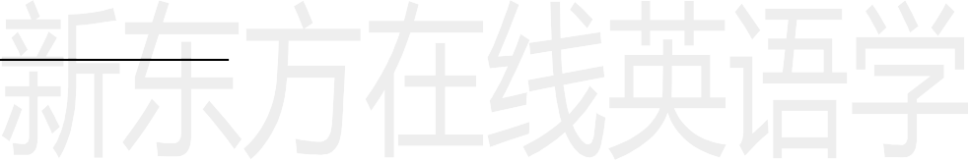If you had joined us, we would have had more fun. Had you joined us, we would have had more fun.

if 虚拟条件状语从句省略 if 可以倒装

If I were you, I would think it twice. Were I you, I would think it twice.

if 虚拟条件状语从句省略 if 可以倒装

If there had not been a hard layer of rock beneath the soil, they would have completed the job in a few hours.

Had there not been a hard layer of rock beneath the soil, they would have completed the job in a few hours.

if 虚拟条件状语从句

If I could rearrange the alphabet, I would put U and I together. If I were to live my life over again, I would have you as my wife.

本课重点:

复习 if 真实／虚拟 两种条件状语从句补充：虚拟条件句省略 if，倒装

